Research Project

The Triangle Factory Fire raised issues about inadequate workplace safety, labor rights, and factory jobs. Despite great progress in improving working conditions since 1911, these issues are still in the news.
Write a research paper about a recent event that shares features with the Triangle Factory Fire.
- Use online and print resources to learn about a recent event.
- Use several sources to get varied viewpoints and interpretations of the event.
- Write a research paper telling what happen, describing the people involved and discussing any issues surrounding the event.
- End your research paper by telling how this event is similar to and different from the Triangle Factory Fire.
- After rehearsing, deliver a presentation to the class.

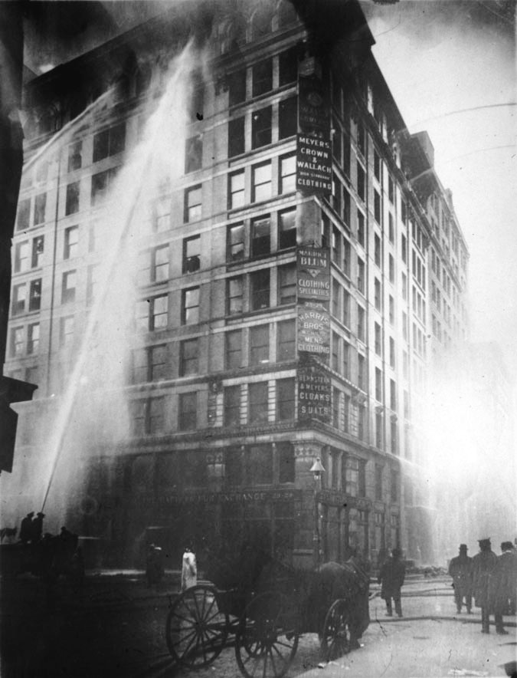
RUBRIC:
_______ Research outline (must be typed)
_______ Minimum of 3 sources relating to your topic
_______ Research Paper
_______ Compare and Contrast of the Triangle Factory Fire
_______ Presentation

IMPORTANT DUE DATES:
Sources Due: ___________________________________
Outline Due: ___________________________________
Research Paper Due: ____________________________
Presentation Due: ______________________________

