The Fault in Our Stars
By: John Green

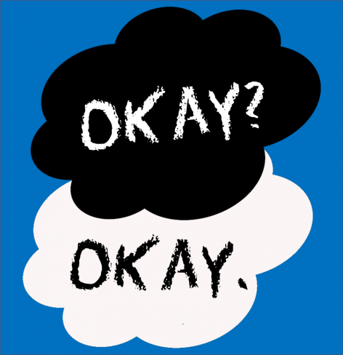
Discussion Questions
1. John Green derives his book's title from a famous line in Shakespeare's Julius Caesar: "The fault, dear Brutus, is not in our stars, but in ourselves, that we are underlings." (I,ii,139-140). What does the line mean—and why would Green have used it for his title? Even more important, why would he have altered it to read, "The fault in our stars" rather than ourselves? How does Green's meaning differ from Shakespeare's?
2. How would you describe the two main characters, Hazel and Gus? Do either of them conform, in behavior or thinking, to what we normally associate with young cancer patients? How do the two differ from one another...and how do their personality traits and interests complement each other?
3. How do Hazel and Gus each relate to their cancer? Do they define themselves by it? Do they ignore it? Do they rage at life's unfairness? Most importantly, how do the two confront the big questions of life and death?
4. Do you find some of the descriptions of pain, the medical realities that accompany cancer, or the discussion of bodily fluids too graphic?
5. At one point, Hazel says, "Cancer books suck." Is this a book about cancer? Did you have trouble picking up the book to read it? What were you expecting? Were those expectations met...or did the book alter your ideas?
5. John Green uses the voice of an adolescent girl to narrate his story. Does he do a convincing job of creating a female character?
7. Hazel considers An Imperial Affliction "so special and rare that advertising your affection for it feels like a betrayal." Why is it Hazel's favorite book? Why is it so important that she and Gus learn what happens after its heroine dies? Have you ever felt the same way about a book as Hazel does—that it is too special to talk about?
8. What do you think about Peter Van Houten, the fictional author of An Imperial Affliction? This book's real author, John Green, has said that Van Houten is a "horrible, horrible person but I have an affection for him." Why might Green have said that? What do you think of Van Houten?
9. Green once served as a chaplain in a children's hospital, working with young cancer patients. In an interview, he referred to the "hero's journey within illness"—that "in spite of it, you pull yourself up and continue to be alive while you're alive." In what way does Green's comment apply to his book—about two young people who are dying? Is theirs a hero's journey? Is the "pull yourself up" phrase an unseemly statement by someone, like the author or any reader, who is not facing a terminal disease?
10. What did you make of the book's humor? Is it appropriate...or inappropriate? Green has said he "didn't want to use humor to lighten the mood" or "to pull out the easy joke" when things got hard. But, he said, he likes to write about "clever kids, [and they] tend to be funny even when things are rough." Is his use of humor successful? How did it affect the way you read the book?
11. After his chaplaincy experience, Green said he believed that "life is utterly random and capricious, and arbitrary." Yet he also said, after finishing The Fault in Our Stars that he no longer feels that life's randomness "robs human life of its meaning...or that it robs even lives of people who don't get to have full lives." Would you say that the search for meaning—even, or especially, in the face of dying—is what this book explores? Why...or why not?
12. How do Hazel and Gus change, in spirit, over the course of the novel?
13. Talk about how you experienced this book? Is it too sad, too tragic to contemplate? Or did you find it in some way uplifting?

